**UNIVERSITY OF CENTRAL PUNJAB**

**Sialkot Pakistan**



A Project report on

**“LIBRARY MANAGEMENT SYSTEM”**

**In partial fulfillment of the requirements for the 3rd Semester Project-I for my BSCS degree at the University of Central Punjab.**

|  |  |  |  |  |  |  |
| --- | --- | --- | --- | --- | --- | --- |
|  | **Submitted By: -** | | |  | **Submitted To: -** | |
| **1)** |  | **Ibrahim Tariq** |  |  |  |  |
| **2)** |  | **Usama Ali** | | **University of Central Punjab** | | |

1. **Bushra Sarfaraz**

**Under The Guidance of**

**Ms. Sheeza Shabbir**

**Subject Teacher, BSCS**



**CERTIFICATE**

This is to certify that the project work entitled **“LIBRARY MANAGEMENT SYTEM”** is carried out by **Ibrahim Tariq (05), Usama Ali (10), Bushra Sarfaraz (74),** students of **UCP** in partial fulfillment for the 3rd semester project during the year **2023-2024**. It is certified that all corrections indicatedfor internal assessment have been incorporated in the report submitted in the department library. The project report has been approved, as it satisfied the academic requirements in respect of the project work prescribed for the said degree.

The details of the students are as follows: -

|  |  |  |
| --- | --- | --- |
| **NAME** | **REGISTRATION NO.** | **SYMBOL NO.** |
| Ibrahim Tariq | SKFUBSCS005 | 05 |
| Usama Ali | SKFUBSCS010 | 10 |
| Bushra Sarfaraz | SKFUBSCS077 | 77 |

Course Semester: - 3rd Semester

Subject: - Project-I

Subject Code: - OOP



Ms. Sheeza Shabbir

Program Coordinator, UCP

**ABSTRACT**

The purpose of **“Library Management System”** is to automate the existing manual system by the help of computerized equipment’s and full-fledged computer software, fulfilling their requirements, so that their valuable data/information can be stored for a longer period with easy accessing and manipulation of the same. The required software and hardware are easily available and easy to work with.

**Library Management System,** as declared above, can lead to error free, secure, reliable and fastmanagement system. It can assist the user to concentrate on their other activities rather to concentrate on the record keeping. Thus, it will help organization in better utilization of resources. The organization can maintain computerized records without redundant entries. That means that one need not be distracted by information that is not relevant, while being able to reach the information.

The aim is to automate its existing manual system by the help of computerized equipment and full-fledged computer software, fulfilling their requirements, so that their valuable data/information can be stored for a longer period with easy accessing and manipulation of the same. Basically, the project describes how to manage for good performance and better services for the clients.

**According’s:** LMS refers to Library Management System.

TABLE OF CONTENTS

Chapter 1 1

INTRODUCTION 1

PROBLEM STATEMENT 2

OBJECTIVES 2

SCOPE 2

ADVANTAGES 3

Chapter 2 4

SYSTEM DESIGN 4

ALGORITHM 4

FLOWCHART 5

ER DIAGRAM 6

Chapter 3 7

REQUIREMENTS ANALYSIS & SYSTEM IMPLEMENTATION 7

SYSTEM METHODOLOGY 8

3.1.1 Requirement and Gathering Analysis 9

3.1.2 System Design 10

3.1.3 Implementation 11

3.1.4 Integration and testing 11

3.1.5 DEPELOYMNET AND MAINTANANCE 12

Chapter 4 13

CONCLUSION & FUTURE SCOPE 13

References 14

Appendices 15

4.1.1 Screenshots 15

4.1.2 Source code 24

# 

## INTRODUCTION

The LMS has been developed to override the problems prevailing in the practicing manual system. This software is supported to eliminate and, in some case, reduce the hardships faced by this existing system. Moreover, this system is designed for the particular need of the library departments to carry out operations in a smooth and effective manner.

Library Management System is a desktop-based application. This application is developed by using C++ language. It is an easy and time-efficient way of storing the data. These data can be easily accessed by the administration.

Library Management System (LMS) is a system which helps users to insert, name, edit, rename, issue and time & date. By using this system, it will help in control the loss of book. The library staffs can get the right information in time and make further Planning.

This system is developed by using “C++” as its backend and This application based on file handling in C++, where I have used a file-related function like fopen, fread, fwrite, etc good thing is that “Library Management System project” is password-protected, so only authorized person able to login in this application.

The project demonstrates the creation of a user interface of a system, without the use of C++ Graphics library. The project uses basic C++ function to generate menus, show message boxes and print text on the screen.

## PROBLEM STATEMENT

A Library Management System has to be developed for automating the Library Management System. Our software provides following facilities: -

* More manual work and effort spent on their respective working areas.
* No backup data record of books.
* Time consuming.

## OBJECTIVES

The main objectives behind the development of this project are as follows:

* To utilize the information of Books.
* To store and retrieve books items.
* To manage the particular records of student.
* To provide the details of issue books.

Thus, there are a number of objectives behind developing the “LIBRARY MANAGEMENT SYSTEM” and it reduces a lot of manuals working of the department. [1]

## SCOPE

The scope of this project is as follows:

* To assist the staff in capturing the effort spent on their respective working areas.
* To utilize resources in an efficient manner by increasing their productivity through automation.
* The system generates types of information that can be used for various purposes.

Thus, there are information scopes behind developing the “LIBRARY MANAGEMENT SYSTEM” and it reduces a lot of burden of the entry.

# 

## SYSTEM DESIGN

## ALGORITHM

Step 1: Start

Step 2: Welcome Message. Press any key to continue

Step 3: Login! Choose Login option.

Step 4: If choice is Student than goto step 5 If choice is Librarian, then goto step 6

Step 5: Display Student menu.

Step 5.1: Enter choice between 1 to 4.

Step 5.2: If choice is 1 show View Book List

Step 5.2.1: Display Choose Branch

Step 5.2.2: Display Book List

Step 5.3: If choice is 2 Search for a Book

Step 5.3.1: Display Choose Branch

Step 5.3.2: Display Search option as shown on figure 9

Step 5.4: If choice is 3 goto step 3

Step 5.5: If choice is 4 goto step 10

Step 6: If login details match, goto step 7. Else goto step 3.

Step 7: Display “Login is Successful”

Step 8: Display Librarian menu.

Step 8.1: Enter choice between 1 to 7.

Step 8.2: If choice is 1 then open View Book List

Step 8.2.1: Display Choose Branch

Step 8.2.2: Display Book List

Step 8.3: If choice is 2 then open Search for a Book

Step 8.3.1: Display Choose Branch

Step 8.3.2: Display Search option

Step 8.4: If choice is 3 then open Modify/Add Book

Step 8.4.1: Display Choose Option

Step 8.5: If choice is 4 then open Issue Book

Step 8.5.1: Display option menu

Step 8.6: If choice is 5 then goto step 3

Step 8.7: If choice is 6 then open change password

Step 8.8: If choice is 7 then goto step 10

Step 9: If choice is 6 “Quit”;

Step 15.1: Close the program. Else Display “Invalid choice”

Step 15.2: goto step 7.

Step 10: Stop

## FLOWCHART

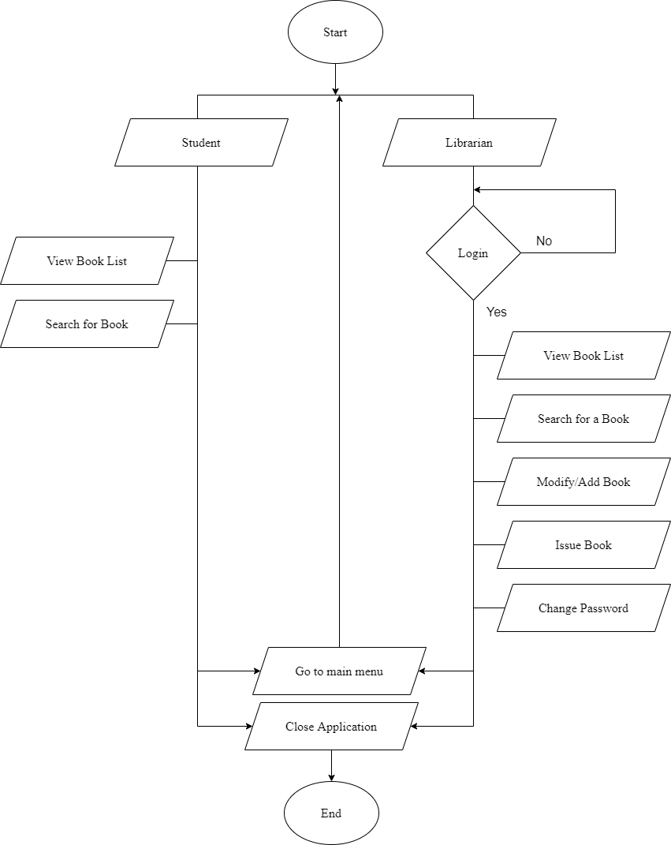

Figure 1 Flow Chart

## ER DIAGRAM

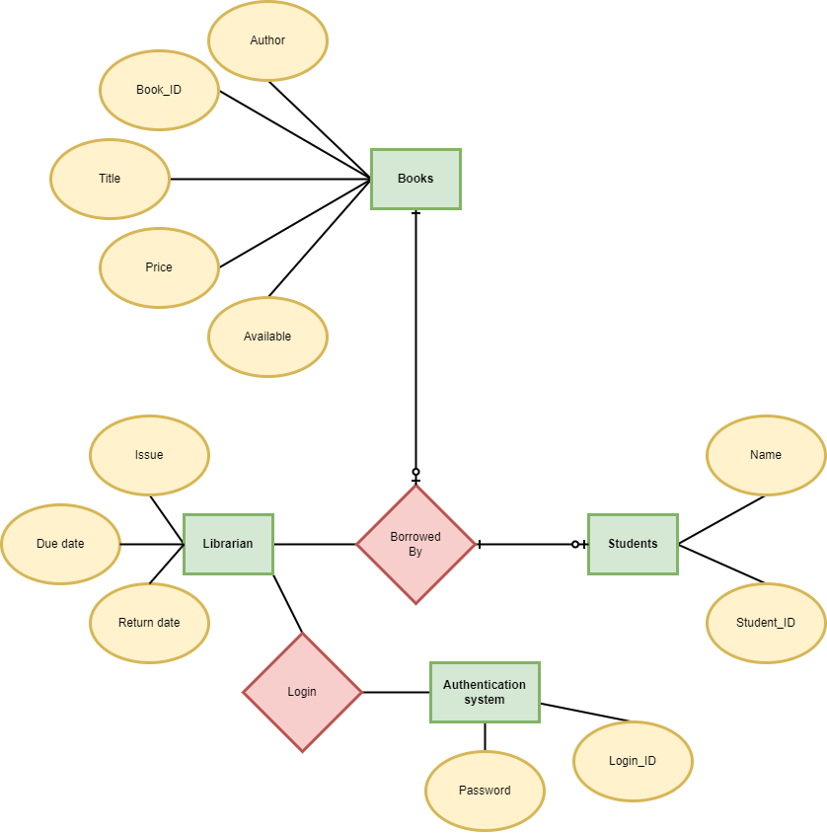

Figure 2 ER Diagram

# 

## REQUIREMENTS ANALYSIS & SYSTEM IMPLEMENTATION

Following hardware and software requirement should be met for flawless running of this system:

**Hardware:** Hardware is the collection of physical parts of a computer system. This includes the computer case, monitor, keyboard, and mouse. It also includes all the parts inside the computer case, such as the hard disk drive, motherboard, video card, and many others. Computer hardware is what you can physically touch.

**MINIMUM REQUIREMENTS:**

**PROCESSOR**: PENTIUM-II

**SPEED**: 1.5Hz

**RAM**: 32MB

**HARDDISK**: 20MB (At least 80MB of free space)

**MONITOR**: VGA COLOR MONITOR

**Software:** Software is a set of instructions, data or programs used to operate computers and

execute specific tasks. It is the opposite of hardware, which describes the physical aspects of a computer.

**OPERATING SYSTEM**: WINDOWS XP, 2000 Professional

**COMPILER**: DEV C++

## SYSTEM METHODOLOGY

**WATERFALL MODEL**

The waterfall model is a classical model used in system development life cycle to create a system with linear and sequential approach. It is termed as waterfall because the model develops systematically from one phase to another in a downward fashion. This model is divided into different phase and the output of one phase is used as the input of the next phase starts and there is no overlapping of the phase. [2]

The sequential phases described in the Waterfall model are:

Requirement gathering and analysis

Implementation

System Design

Integration and Testing

Deployment and Testing

Figure 3 Waterfall Model

### Requirement and Gathering Analysis

**FUNCTIONAL REQUIREMENT**

In software and system engineering, a functional requirement defines a function of a system or its component, where a function is described as a specification of behavior between input and outputs

Figure 4 User case diagram

**Student**



**Librarian**

### System Design

In this phase we designed the algorithm and flowchart required for the development of the system.

System design is the process of designing the architecture, components, and interfaces for a system so that it meets the end-user requirements. A good system design is to organize the program modules in such a way that are easy to develop and change. There are many strategies or techniques for performing system design.

* **Importance**:
* If any pre-existing code need to be understood, organized, and pieced together.
* It is common for the project team to have to write some code and produce original programs that support the application logic of the system.

#### Functional Analysis

|  |  |  |
| --- | --- | --- |
| **No.** | **Function module** | **Function Description** |
| **1.** | **login ()** | This function is for security purpose so that person other than admin cannot manipulate the system or program. |
| **2.** | **insertData ()** | This function opens the binary file in append mode and writes the book and the details. |
| **3.** | **searchData ()** | This function opens the binary file in reading mode and asks the user to enter the book name which wants to search. |
| **4.** | **displayData ()** | It opens the file in reading mode and read and display all the stored book details. |
| **5.** | **deleteData ()** | This function asks the book id form the user for the book want to delete. In this function, I am creating a temporary binary file and copy all the data from the existing file except the book whose book id entered by the user. In the last renamed the temporary bin file with a existing binary file. |
| **6.** | **updateData ()** | This function opens the file in rb+ mode (reading and writing). It asks the user for the new data |
| **7.** | **checkBookNo ()** | This function compares the old book id to new book id. if the book id match, then display the book id which you typed just now, is already exists. |
| **8.** | **findlastBookNo ()** | This function displays the last duplicate book id. and asks to enter a unique book id no. |

### Implementation

It is the process of using the project in client’s computer. After the executive file has been created, this project can be copied from saved source to any secondary storage device and pasted to the required system. The project can be operated by opening it, completely replacing the existing manual system.

### Integration and testing

Testing in a project development is a very important task to find out the possible mistakes made by the developers. The system cannot give the correct output until the project contains no errors at all. This project has checked the possible errors by using the following approaches:

1. Black Box Testing Approach: This approach concentrates on the basic requirements of the project. It simply checks direct matching of records of particular book, after we select a book no of a particular student.
2. White Box Testing Approach: This approach concentrates on the actual codes written during the development of the project. It checks every line of codes in all the functions of the program.

This project has fully tested by using both approach’s and ensures the correct output

### DEPELOYMNET AND MAINTANANCE

When time changes, the requirements of the organization also changes and this project can no longer fulfill its requirements. The changes are necessary to keep the project running and useful to college. Maintenance may be required when the college changes its requirements.

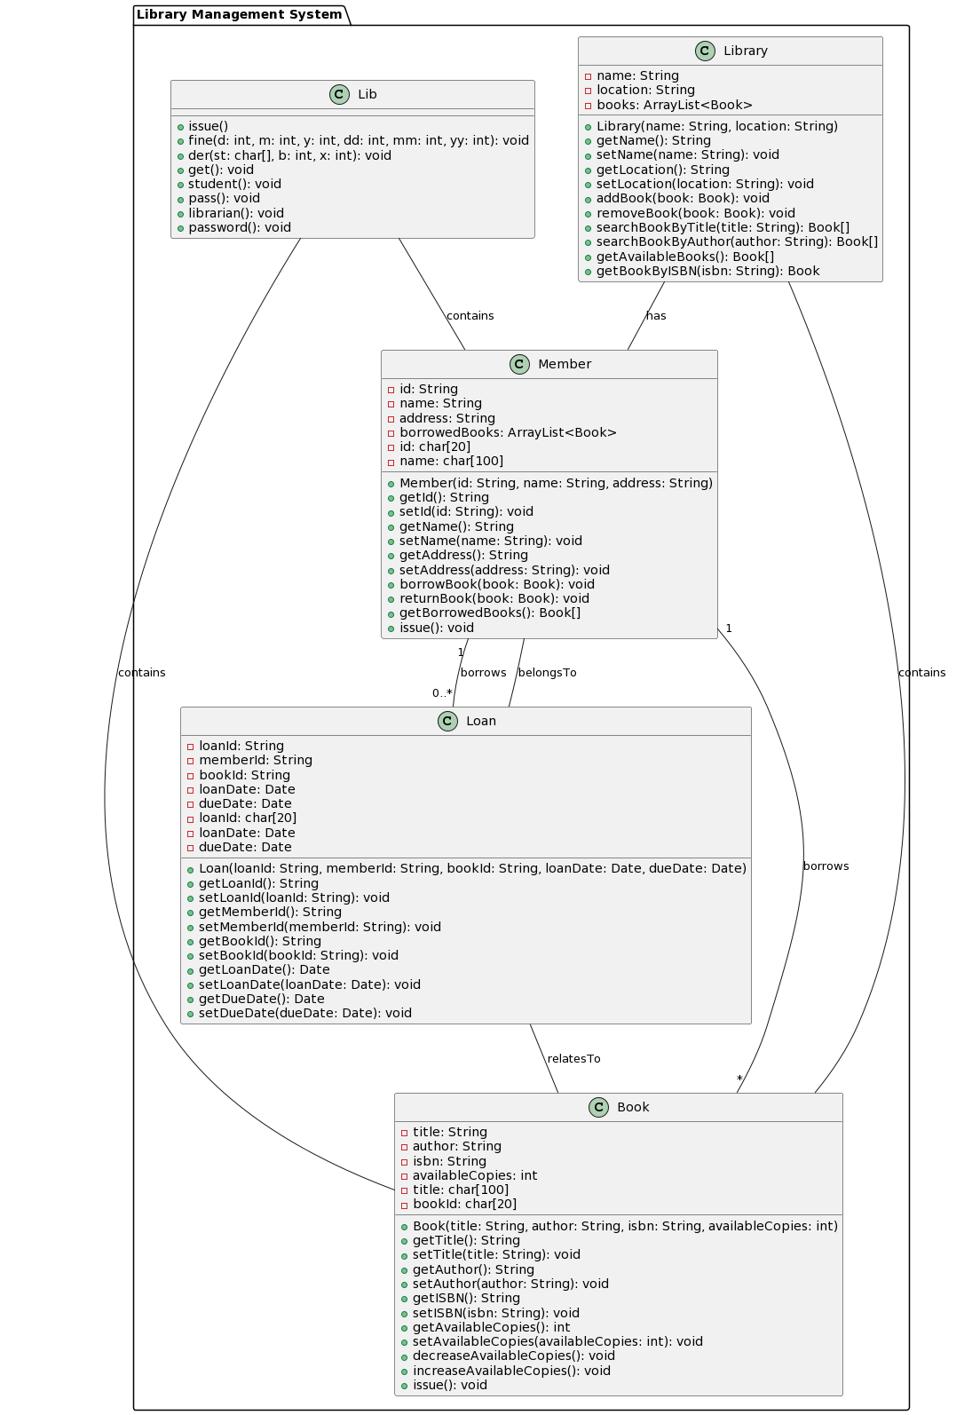

# 

## CONCLUSION & FUTURE SCOPE

**CONCLUSION**:

Our project is only a humble venture to satisfy the needs to manage the project work. Several user-friendly coding has also adopted. This package shall prove to be a powerful package in satisfying all the requirements of the school and college. The objective of software planning is to provide a frame work that enables the librarian to keep the record of the book within a limited time.

Our project provides a computerized version of library management system which will be beneficial for the students as well as the staff of the library.  
It makes entire process easy where student can search books, staff can generate reports and do book transactions. It also has a facility for login where library staff can login and can see status of books issued.

**FUTURE SCOPE:**

There is a future scope of the project with addition to the facilities as follows: -

1. We can provide online facilities for ordering and searching the availability of books.
2. We can add login page for individual students.
3. User interfaced can be made attractive.

## Appendices

### Screenshots

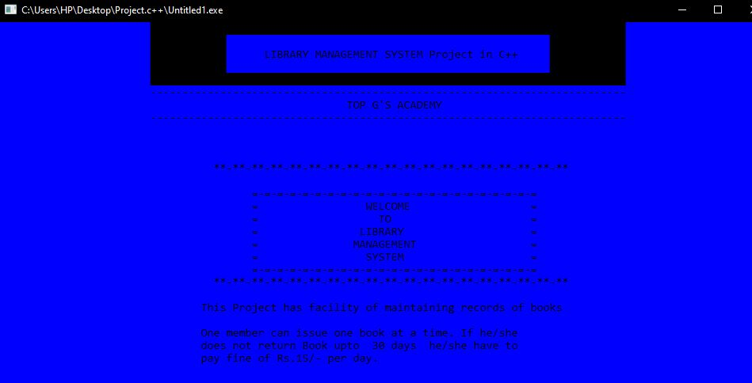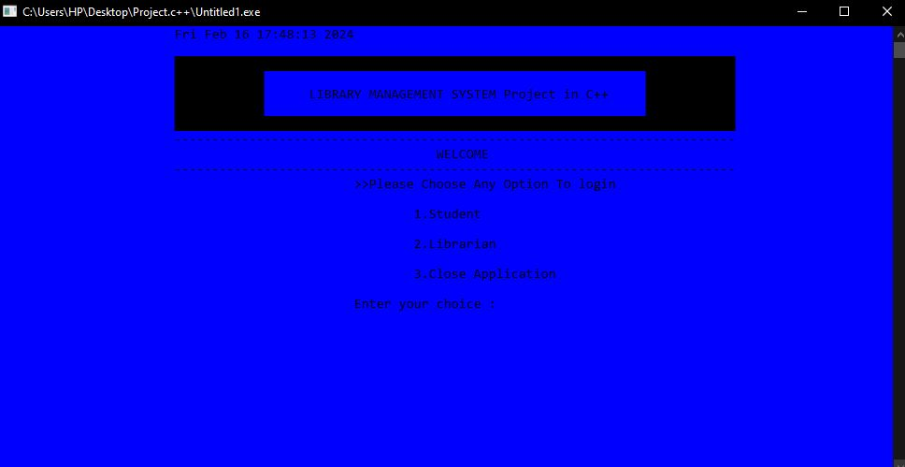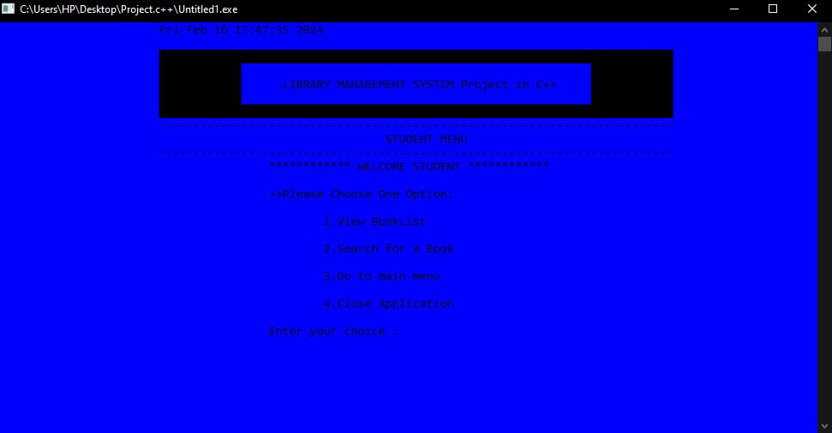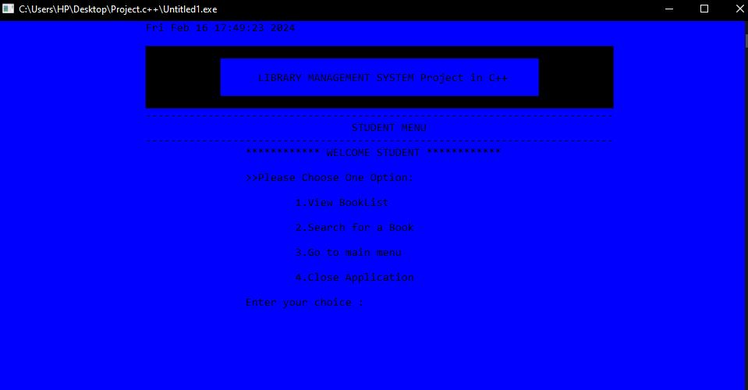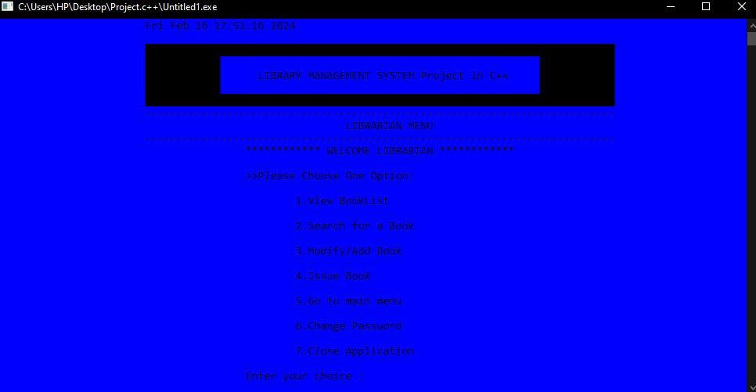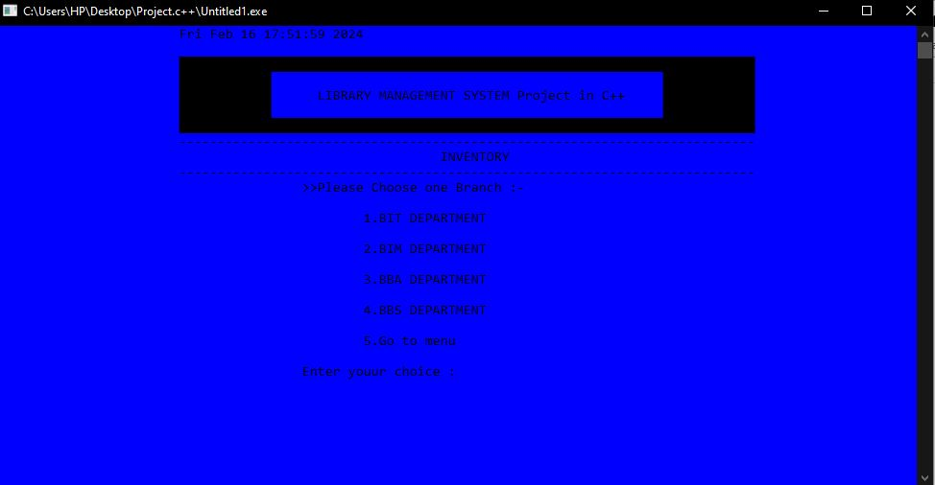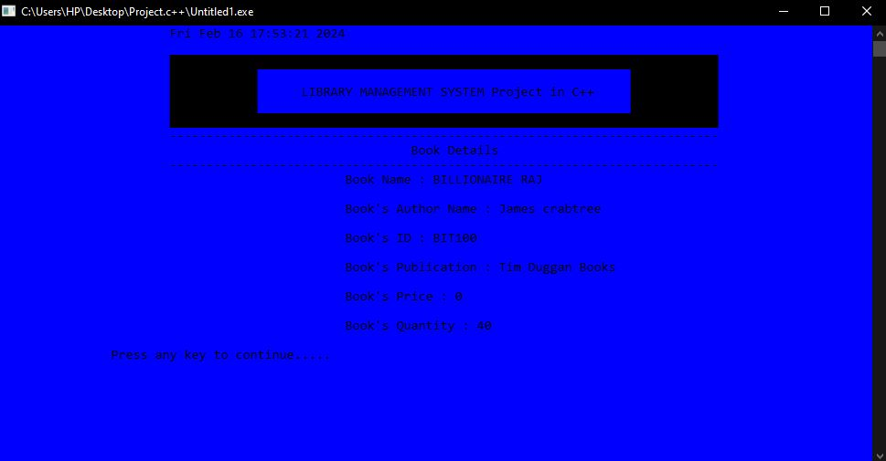

### Source code

//*****************************************************************************************

Available on Github

//*****************************************************************************************